TOMMY HILFIGER ANNOUNCES TOMMY JEANS COLLABORATION WITH LONDON LUXURY STREETWEAR BRAND ARIES
The collaboration is an empowering and creatively subversive play on all things modern prep, including limited-edition pieces handcrafted from existing garments.

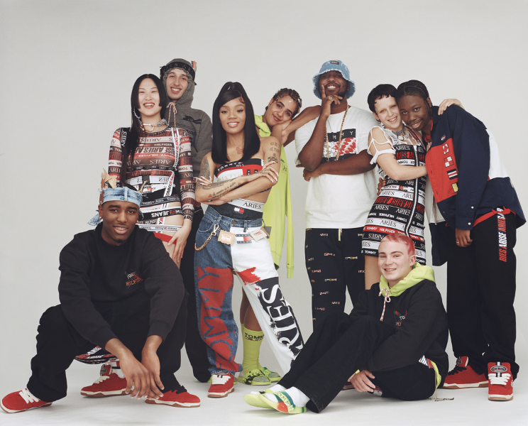

AMSTERDAM, THE NETHERLANDS (FEBRUARY 2023) – Tommy Hilfiger, which is owned by PVH Corp. [NYSE: PVH], is excited to announce its newest collaboration with London-based luxury streetwear brand, Aries. The collection focuses on shared silhouettes and proportion play, detailed by Aries' handcrafted and distressed techniques to reimagine classic Tommy codes.

The 35-piece menswear, womenswear and footwear Tommy x Aries collection is inspired by TOMMY JEANS’ archives and updated through an Aries lens. A powerful play of exaggerated proportions on layers and denim are seen throughout the collection, bringing a distinct Aries luxury streetwear vibe to modern prep. Key items include the jacquard tape logo dress and black trucker jacket with a 5-pocket matching pant, and a relaxed indigo denim jacket and baggy split colorway screen-printed denim pant.

Supporting TOMMY HILFIGER’s sustainability vision to Waste Nothing and Welcome All, a curated selection of pieces within the collection are from Tommy x Aries: Remade, one-of-a-kind items handcrafted by Aries from existing garments – derived from post-consumer waste and surplus materials. Styles for women include irreverent corsets made from the Tommy flag and upcycled denim, cut-out vintage tees, jacquard tape harnesses and a three-shirt asymmetrical jersey dress. Menswear delivers remade Tommy flags and graffiti emblems splashed across vintage t-shirts and hoodies.

Delivering maximum impact, the campaign approach places emphasis on the design and construction of the individual styles – leveraging a real and raw aesthetic with a disruptive edge and engaging energy. The creative red thread of ‘hacking’ is brought to life through the art direction of each individual image, utilizing patches, tape bands and artwork – in essence, the individual components of each product, adding to the overall narrative.

Photographer Angelo Pennetta brings his unique lens to the collaboration and carefully constructs the campaign to create a striking portfolio of images. His lookbook features GRAMMY nominated rapper GloRilla, grime artist Novelist, and Aries family 5EB, Brian Tshabola, Haajar Djouada, Kasper Kapica, Kirbs, Nathan Rosen and Xiao Wang.

A film by Aries founder and Creative Director Sofia Prantera will be released to complement the campaign featuring an instrumental version of GloRilla’s ‘Unh Unh’ with special verses by Novelist, Kirbs and 5EB as the film smoothly flows with bold visuals that nod to moments in TOMMY JEANS’ hip-hop history.

The campaign will launch in London where new media forms will be subverted and hacked as flyposting and street markings can be scanned by mobile, directing passers-by to the nearest store. Once there, the audience can experience the collection by engaging in an AR virtual-try on. Aries’ new London flagship home will celebrate the launch hosting an event bringing together the creative cast.

Aries is a non-gendered, luxury streetwear brand made in Italy and created in London. Founded by Sofia Prantera, Aries was born out of an ongoing love of trash culture, outsider art, graphics and illustration. The brand reflects Sofia's Saint Martin's background as well as her forensic approach to garment construction, dyeing and printing. Its cultural output takes the form of self-published books, international art shows, exhibitions, experiences and collaborations which range from the cult and collectable to the esoteric.

The collection will be available starting on March 31, 2023, at select Tommy Jeans stores and wholesalers, on tommy.com and at the Aries store in London. Join the TOMMY JEANS community on social media via @TommyJeans, @Ariesarise, #TommyJeans and #TommyxAries.

# # #
About TOMMY HILFIGER

TOMMY HILFIGER is one of the world’s most recognized premium lifestyle brands, uplifting and inspiring consumers since 1985. The brand creates iconic style, which comes alive at the intersection of the classic and the new, co-created with people who are shaping culture around the world. TOMMY HILFIGER celebrates the essence of classic American style with a modern twist. Tommy Hilfiger offers premium quality and value to consumers worldwide under the TOMMY HILFIGER and TOMMY JEANS lifestyles, with a breadth of collections including men’s, women’s and kids’ sportswear, denim, accessories, and footwear. Tommy Hilfiger has an unwavering commitment to sustainability and inclusivity.

Global retail sales of TOMMY HILFIGER products were approximately $9.3 billion in 2021 and the brand is powered by more than 16,000 associates worldwide — present in 100 countries and more than 2,000 retail stores, including its largest global flagship store at tommy.com. PVH acquired Tommy Hilfiger in 2010 and continues to oversee a focused approach to growing the brand’s worldwide relevance, presence, and long term growth.

About PVH Corp.

PVH is one of the world’s largest and most admired fashion companies, connecting with consumers in over 40 countries. Our global iconic brands include Calvin Klein and TOMMY HILFIGER. Our over 140-year history is built on the strength of our brands, our team and our commitment to drive fashion forward for good. That’s the Power of Us. That’s the Power of PVH.

Follow us on Facebook, Instagram, Twitter and LinkedIn.

