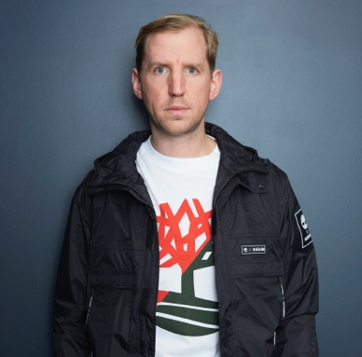
BIO

CHRISTOPHER RAEBURN
GLOBAL CREATIVE DIRECTOR

In October 2018, Christopher Raeburn was named global creative director for Timberland. A British fashion designer with his own label RÆBURN, Christopher is respected worldwide for his responsible and intelligent design ethos. As global creative director for Timberland, he is a key stakeholder in developing the brand’s global creative vision and elevating Timberland’s longstanding commitment to responsible sourcing, inclusivity and community. He works closely with the global product team to deliver a forward-thinking look and feel that pushes design boundaries while honoring the brand’s outdoor heritage.
A graduate of London’s prestigious Royal College of Art, Christopher became known for his re-appropriation of military fabrics and in particular for iconic outerwear created from de-commissioned parachutes. His design ethos encompasses three key pillars – RÆMADE, RÆDUCED, RÆCYCLED – which complement Timberland’s vision to have a net positive impact on nature by 2030. Raeburn also heralds craftsmanship, innovation and utility as central to his design philosophy, again creating a natural and authentic connection to the Timberland brand. His seasonal Earthkeepers^{Ò} by Raeburn collection reflects Timberland’s pinnacle expression of eco-innovation and progressive style, and serves as a pathfinder toward a greener and more equitable future.

Christopher’s pioneering work has brought responsible design to a mainstream fashion audience, and presents a new definition of luxury with integrity. He has won numerous awards over the years, including British Fashion Award for Emerging Talent Menswear in 2011 and GQ Man of the Year in 2015. He was named to the Drapers Power 100 list in 2019, and his label RÆBURN was named Brand of the Year (under £30M) in 2020.

In his free time, Christopher enjoys biking, running, and enjoying the many parks and trails around his home in South London. He is personally driven by a passion for nature, and furthering responsible innovation within the fashion industry to help protect the outdoors for the next generation.

